**Visualization of Property Recovered & Stolen Dataset in India**

**Table Of Contents**

Contents

1.Introduction 4

2. Exploration of Dataset 4

3. Answers 4

4. Visualization of the Dataset 5

# **1.Introduction**

This dataset is about the property stolen and recovered across the states of India which comes under crime. The dataset has 2449 observations and 8 variables. I have taken another dataset which is having longitude and latitude of Indian states and after combining both datasets the total number of observations are 2169 and 11 variables.

**Packages and Library used**

|  |  |
| --- | --- |
| **Packages** | **Library** |
| leaflet | leaflet |
| tidyverse | dplyr |
| ggplot2 | ggplot2 |
| plotly | plotly |
| stringr | stringr |
| gganimate | gganimate |
| scales | scales |
| ggalt | ggalt |
| rbokeh | rbokeh |

# **2. Exploration of Dataset**

I order to start the visualization, dataset has to be clean. The property dataset and the location dataset has different format of states written. I have made the state column from both the dataset in lowercase. Cleared the spacing between the names of state. The strings also has been replaced wherever was necessary.

After cleaning and formatting the dataset both the dataset has been merged by inner join with common category from the dataset which are Area Name from Property dataset and State Name from location dataset.

The final dataset is called merged dataset.

# **3. Answers**

# a)   India has many crime cases and I wanted to work on the crime rates in India. I searched in Kaggle and found many data based on crimes rates in which no one has visualized property stolen and recovered cases across states of India.

b)   No one has visualized on this dataset before.

c)   I used two datasets, one is the main property stolen and recovered dataset, and the other is a combination of longitude and latitude datasets from Indian states. I used multivariate and univariate analysis after integrating the two datasets. The plots shown the various information like the number of property cases and recovered among each states as the increasing number of years and how much are the values of those properties.

To illustrate the dataset, I developed bar charts, scatterplots, boxplots, 3D plots, dumbbell charts, pie chartand various animated bivariate charts. I've also set a public URL so that anyone can view the chart in real time.

d) I discovered the difficulty while displaying the charts dynamically rather than statically. I created the graph using ggplot and the plotly function, but we can only use anim_save to save gif file for ggplot. However, I was having trouble generating the dynamic plot using the plotly function. After experimenting with several methods, I finally found out how to dynamically display plotly charts. I made a plolty account and wrote a code to open the plot immediately on the plotly chart website. Also, plot no. 13 and India map were generated using rmarkdown to dynamically build the plot and publish in rpub. Each of these plots has a public URL listed below.

e)  Receiving property that has been proven to be stolen is illegal. This property could have been obtained through theft, extortion, or any other method. It is a crime because purchasing such property encourages crimes such as theftt, robbery, and so on because the person stealing such property would profit from the sale of the stolen property.

As a result, receiving stolen property is a crime in order to keep thieves from profiting from their criminal activities.

It also forbids the concealment of property by someone who knows it was obtained illegally. A number of provisions in the IPC address the receipt of stolen property. These are outlined in Section 410 of the Code of Federal Regulation

Due to considerations of all of these factors, I made a choice to work on the stolen and recovered cases of India.

f)  The data contains cases of property stolen and recovered across each state of India from 2001 to 2010. There is a pattern recognition in the dataset. It shows the cases are rising as we move towards each increasing year as well as the value of property also increases. The cases of property stolen and recovered is more in Maharashtra as compared to other states.

g)   I would have try shinny and the other ways to generate the plot fully dynamic if I have given more time to improve the work.

# **4. Visualization of the Dataset**

1. The below Histogram is just a univariate analysis of the property stolen, recovered and it’s value. The plot shows the count of the properties.

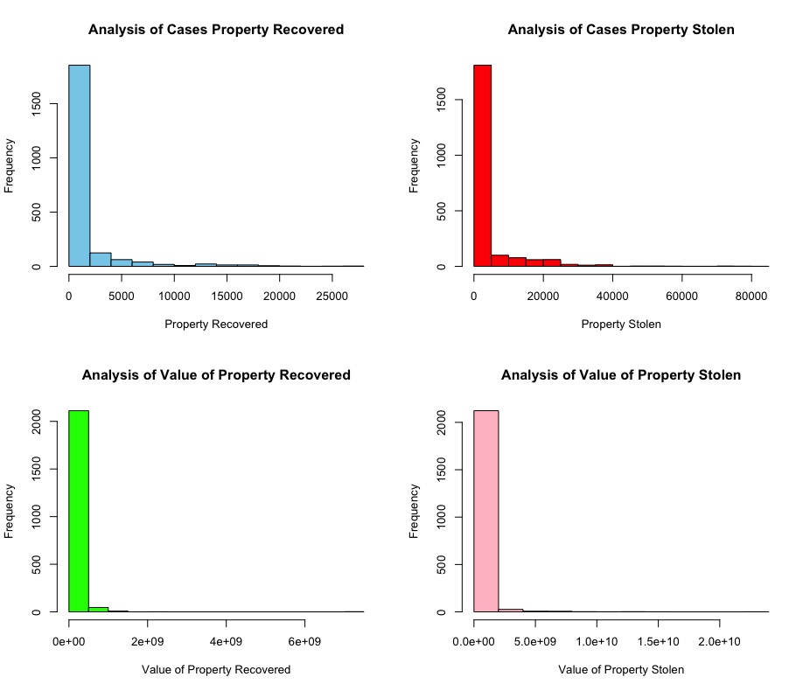

2. The next plot is about the analysis of the value of property recovered by the group name in one frame.

By seeing the plot it can conclude that the most number of value of the property recovered is from the dacoity, other heads of property, criminal breach of trust, burglary is almost same and the least if for total property.

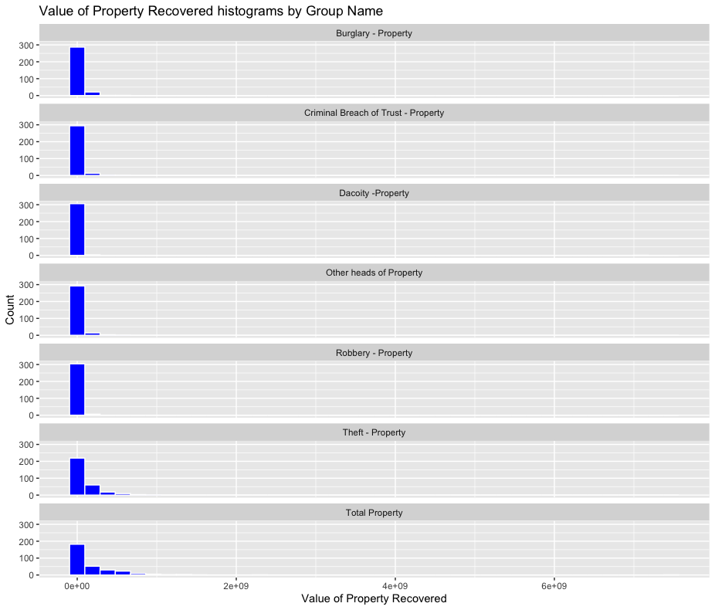

3. This represents the barplot of the analysis of the total number of cases of property recovered across each state of the Indian states. Maharashtra has more number of property cases recovered and Andaman has less cases of property recovered.

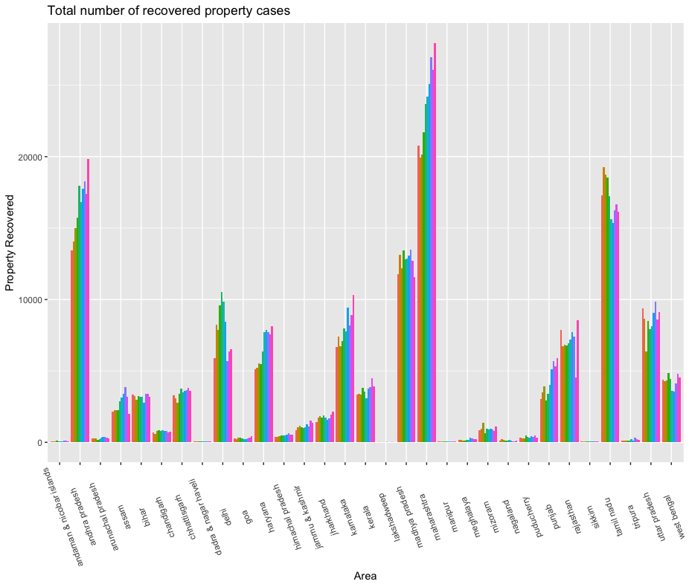

4. The boxplot shows how many stolen property cases has been registered across each states of India. The highest number of cases in Maharashtra and the least cases are in Andaman & Nicobar Islands. Also, Andhra Pradesh, Dadar & Nagar Haveli, Lakshadweep, Sikkim, Tripura, Manipur, Meghalaya has least cases.

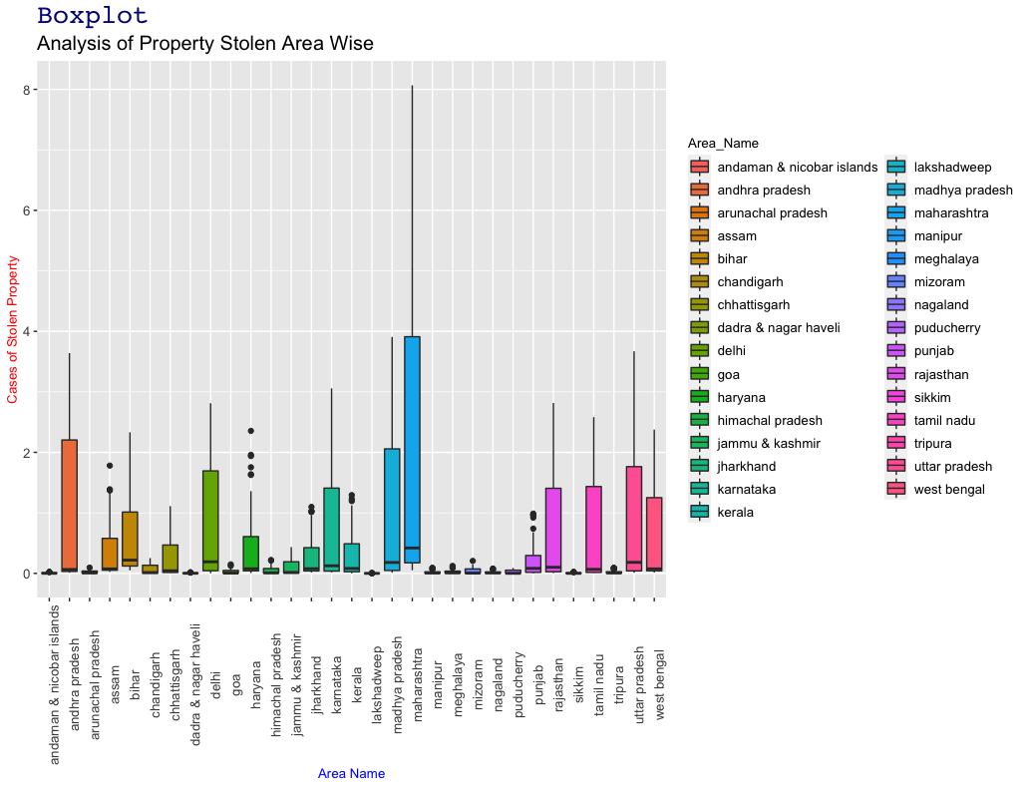

5. The below plot is the analysis of the number of property recovered and how much is the value of the across each state of India. The plot is a combination of line and scatter. With the plot it’s concluded that the value of property recovered is more Lakshadweep, Madhya Pradesh, Maharashtra, Manipur, Meghalaya and Mizoram and less is for Andaman & Nicobar Islands and then slightly increased for Himachal Pradesh, Delhi.

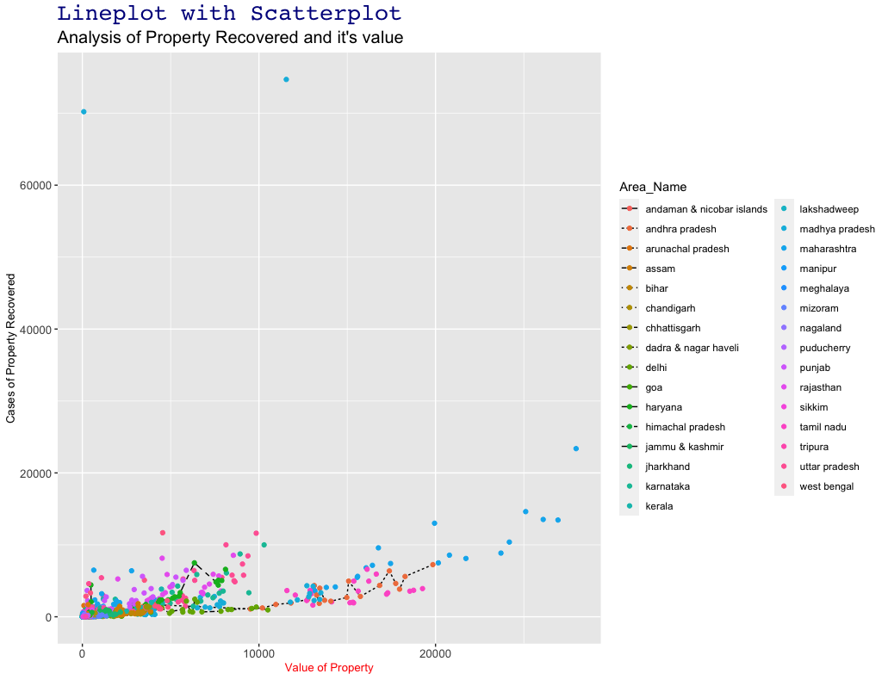

6. As per the plot, it can be concluded that there is a positive linear regression between the total number of property stolen registered and its value across each state of India. The cost of stolen property is increasing as per the number of cases.

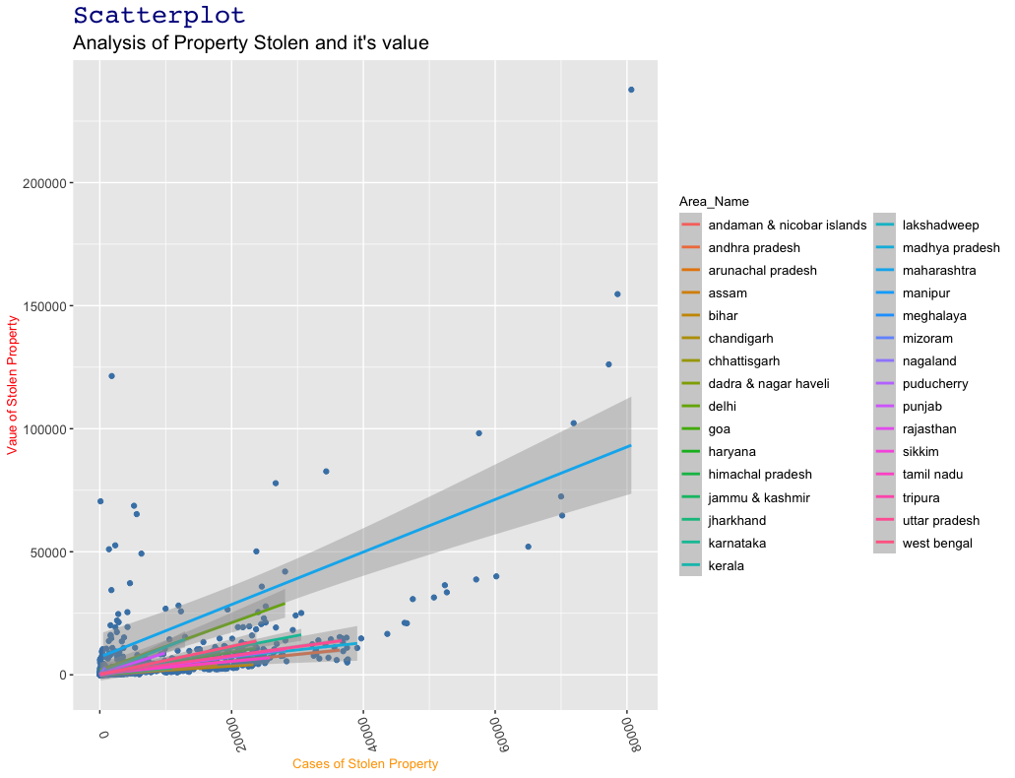

1. Below is the dynamic 3D plot which shows the relationship between the total number of property recovered and its value across the state of India. Here the image is static, I have provided below the plotly weblink to check the plot in 3D. As we hover over all the points which shows the states, the property recovered cases and its value will be visible.

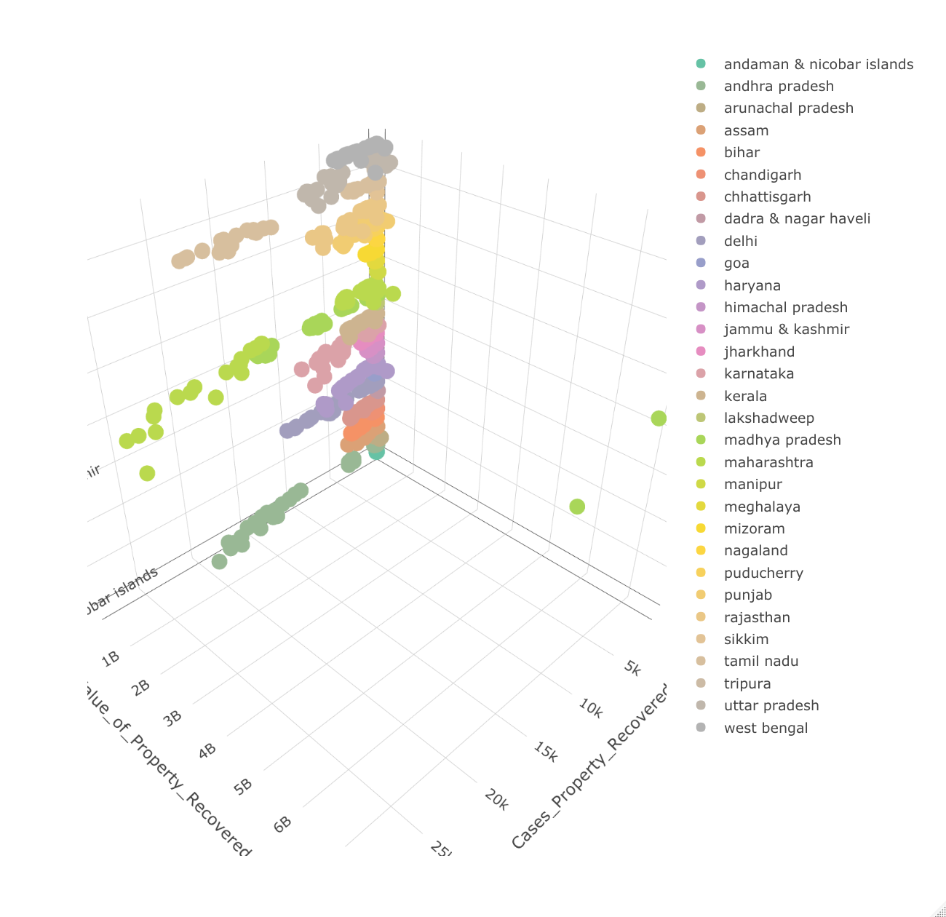

Link: <https://plotly.com/~NupurR00195712/3/>

**8.** This animated bar chart shows the analysis of total number of property cases recovered by the states of India. Here the image is static, I have provided below the plotly weblink to check the animated plot . As we hover over the bars the value of property recovered particular to that area can be seen. The highest value of property is for Maharashtra and the least is for Andaman & Nicobar Islands.

Link: <https://plotly.com/~NupurR00195712/2/>

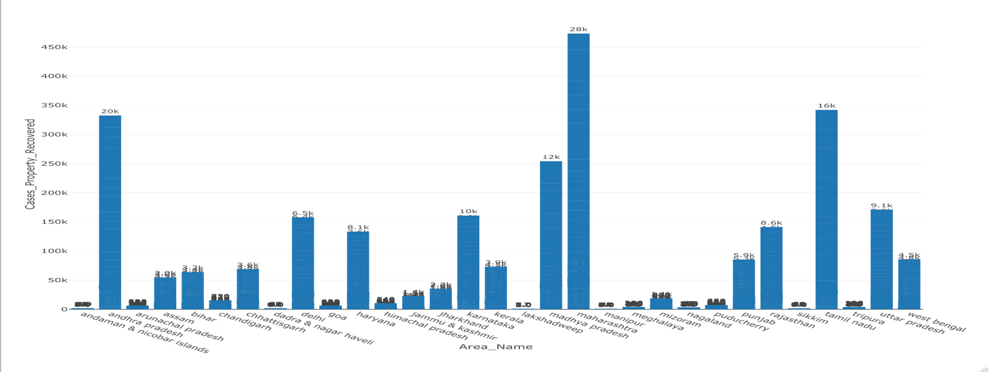

9. This is the dynamic scatterplot between the total number of property stolen between year 2001 to 2010 across each state. As we are moving forward to the years the cases are increasing and its value as well.



10. It’s a dynamic barplot which shows the count of property either its recovered or stolen across each state. Conclusion is Bihar and Haryana has more number of properties and Arunachal Pradesh, Assam, Tripura, Tamil Nadu, Uttar Pradesh, Karnataka has less as compared to others.



11. This automatic pie chart shows the relationship between total number of property cases recovered by states of India. When we hover over the sections we can see the total cases in each state. Here the image is static, I have provided below the plotly weblink to check the animated plot. We can see that Lakshadweep has more percentage of recovered property cases.

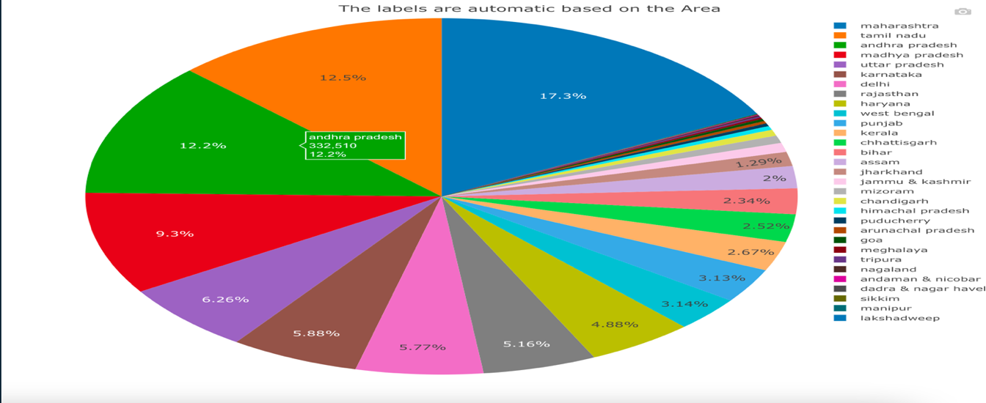

Link: <https://plotly.com/~NupurR00195712/1/>

12. Analysis of number of property stolen cases and its value based on the group of property and size is represented the value of property recovered. I have also added the play button and scroll slider. Instead of creating individual plot by year to check the cases and its value, we can easily scroll the year and can see. Here the image is static, I have provided below the plotly weblink to check the animated plot.

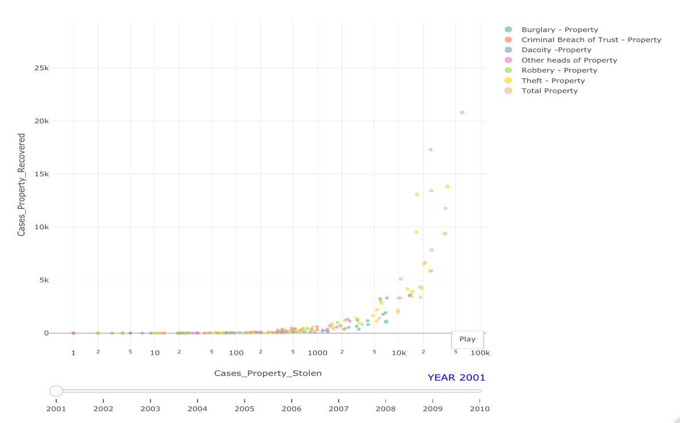

Link: <https://plotly.com/~NupurR00195712/5/>

13. This plot is a combination of all values , groups of property recovered and stolen cases on a single point by simply hover over the points. Here the image is static, I have provided below the rmarkdown html link to check the animated plot.

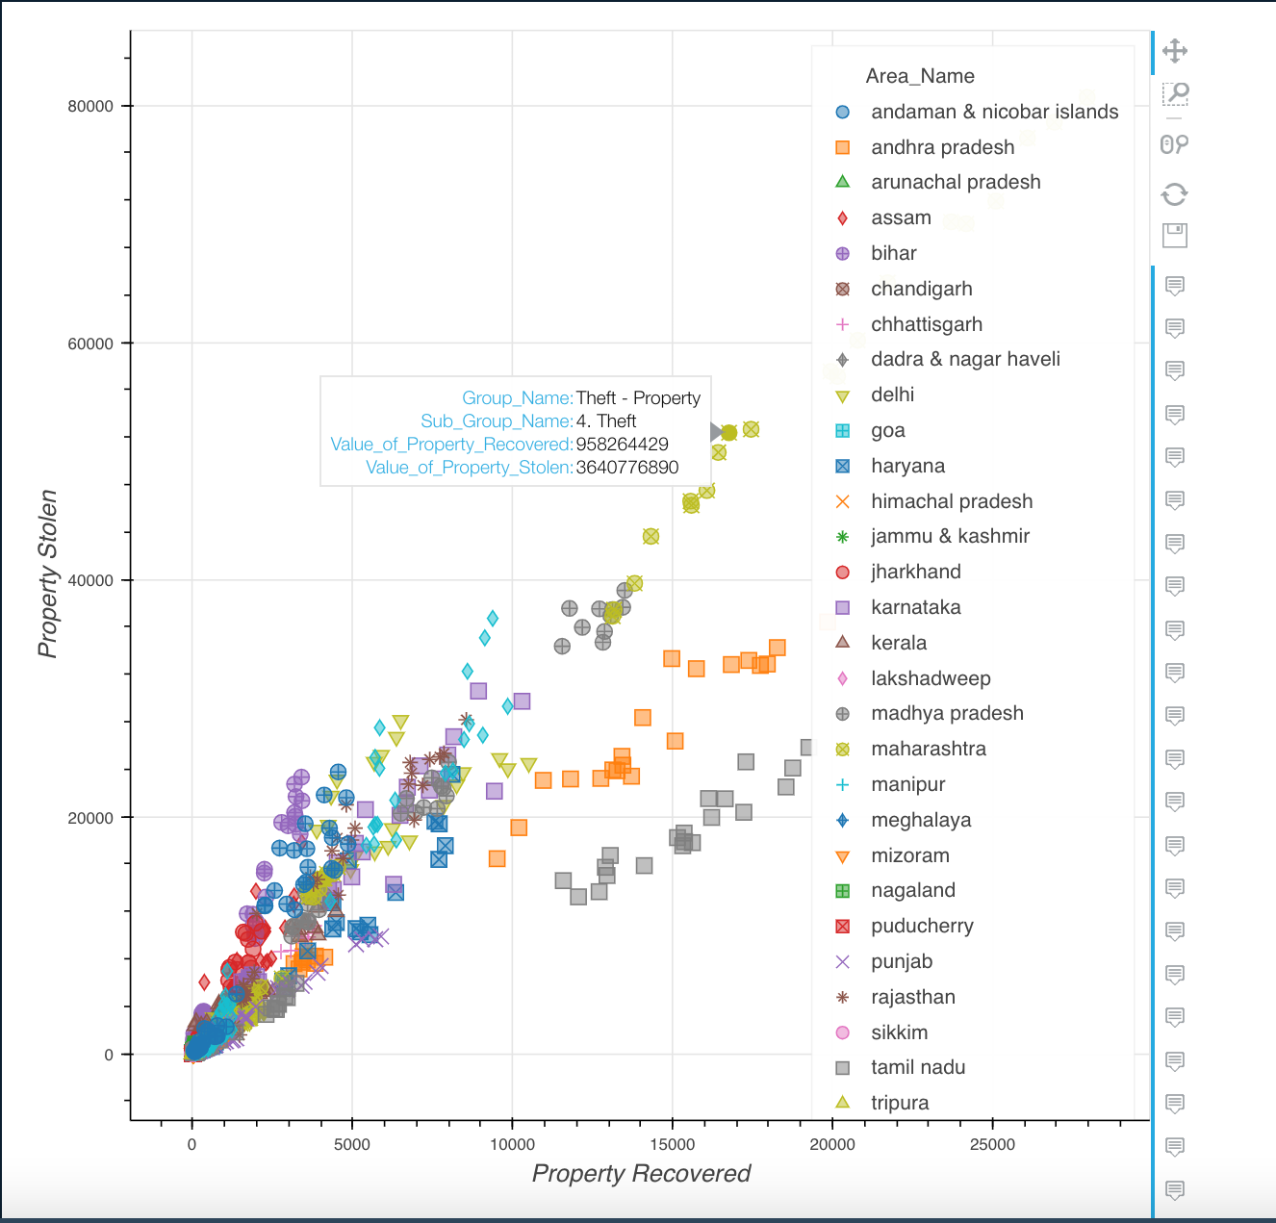

Link: <http://rpubs.com/NupurR00195712/animatedplot>

14. This plot is called dumbbell chart. The graph shows the property recovered, stolen and its value. The majority of cases of property and its value found in the state of Maharashtra and least for Andaman, Dadra, Sikkim.

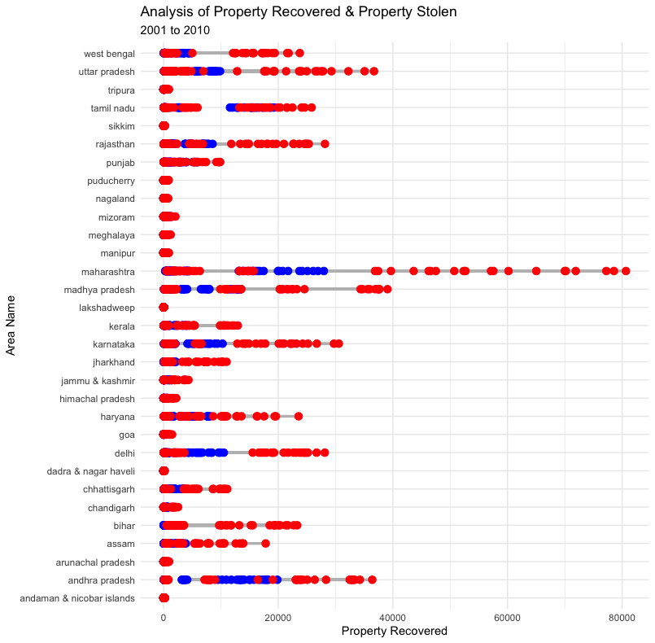

15. The is the geo map of India. Here analysing the number of property cases recovered by sub group name of the property across each state of the India. When we click on state, it will show the maximum number of property stolen and recovered in that particular area. Here the image is static, I have provided below the rmarkdown html link to check the animated plot.

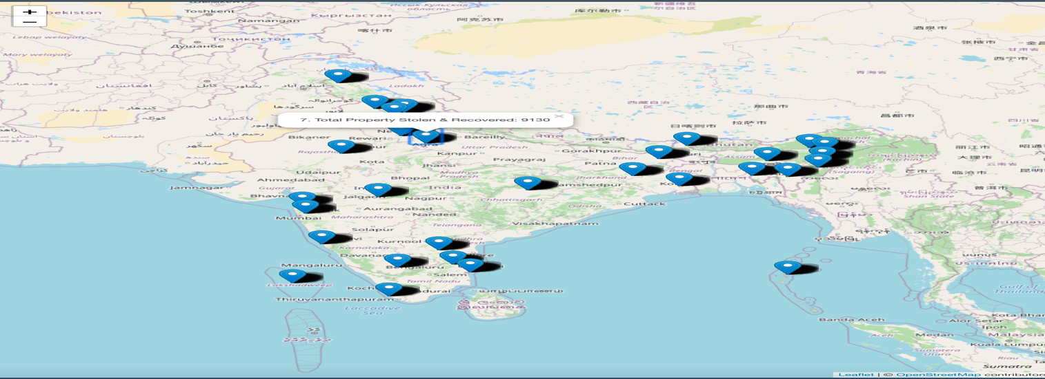

Link: <http://rpubs.com/NupurR00195712/animatedplot>

Kaggle Dataset Link: <https://www.kaggle.com/aurghyadip/eda-of-rape-crimes-in-india/data>